Case Study-ADNOC Expansion
Student’s Name
Date of Submission

PROBLEMS FACED BY ADNOC IN ITS EXPANSION
INTRODUCTION
ADNOC is one of the largest energy company in the world, enjoying a big percentage of the global market due to its commodities' simplified prices. The company has sixteen subsidiary entities in downstream, midstream and upstream. Off late, the Company is carrying on its operations in around twenty-seven countries globally, enjoying a good number of customers. From its annual financial report in the 2012 fiscal year, the Company held the seventh largest proven oil reserves globally with 97.8 billion barrels. The Company's expansion has prepared and enhanced it for other market entries, although the rise of globalization is attracting new investors continually into the retail industry market. This has posed a threat to ADNOC in its strategic expansion plans. However, most of the renowned retailers conversely fail in certain global markets due to various experienced reasons, generally cultural, legal, regulatory, and competition reasons.
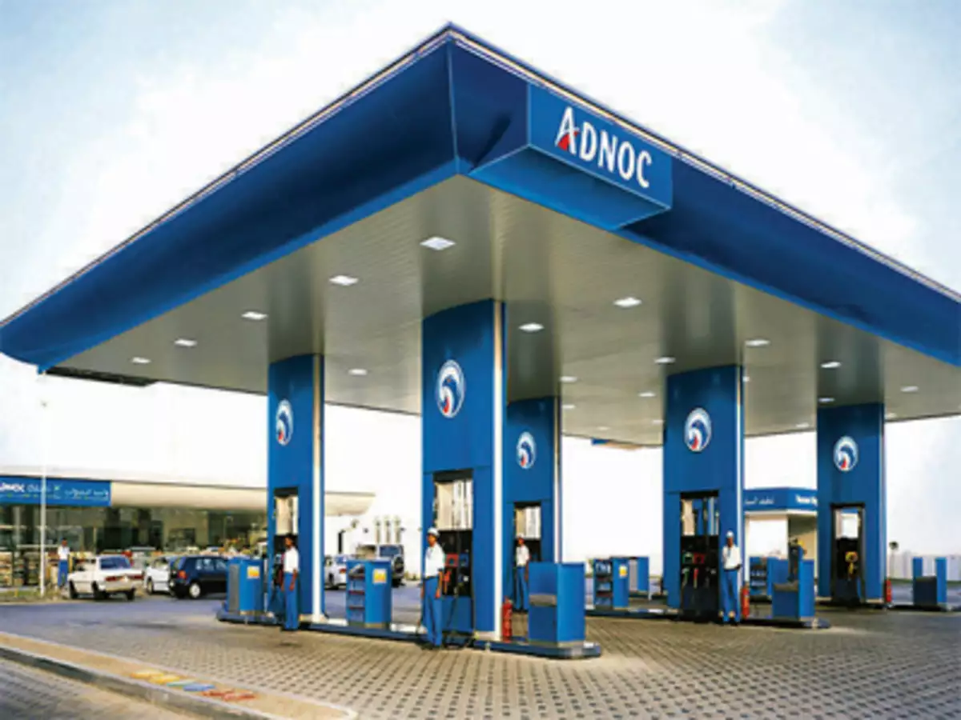
The most productive business of ADNOC is the United Arabs Emirates business producing net sales of 80.6 billion dollars in the 2019 fiscal year that ended on Oct 26, 2018. Nonetheless, the Company's global segment has been incredibly valuable still and producing net sales of $28.8 billion in that particular, fiscal year quarter. However, the Company has been experiencing major issues overseas. ADNOC is currently undergoing major difficulties in its expansion of the operations majorly in Asia better part of it, specifically in India and China. This is as a result of a section of the major cultural and business problems that might be experienced by a global company in its operation expansion attempts into any foreign nation.
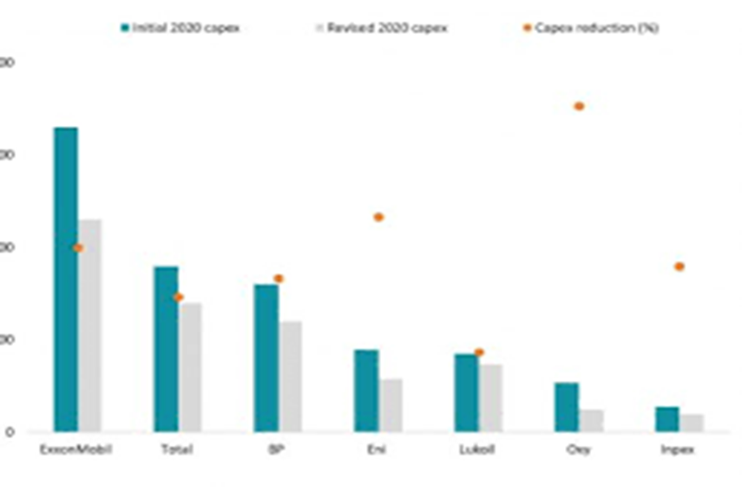
The study elaborates on the global expansion of ADNOC and the problems faced in the venture. The study also examines if ADNOC has the likeliness of penetrating the Asian market with its specific retail strategy in the United States Market.
BACKGROUND INFORMATION
ADNOC is among the largest energy dealer, in fact, the largest in the UAE. Its financial endowment is largely recognized across the globe, and the Company perceives that for a global expansion with its rapid rise in revenues above the one for the UAE. With this particular notion, ADNOC has been exploring diverse markets off late, including the retail market in Asia. However, ADNOC seems to lack the information to appreciate that a particular country's success does not automatically guarantee the same success in another given nation. The Company has been pushed by this reality to open other divisions globally within the organization's structures. The responsibility of international growth chances was mandated to the department where the Division was significantly found to cause a fallback stand for the Company in case of a slowdown of the UAE market. This has facilitated the Company's global penetration in the existing and emerging market.
The strategy also enhanced the acquisition of shares by the Company in major markets like China. However, the operated stores by ADNOC are not established newly since a number of them were attained through acquisitions and joint ventures as well. In Asia, ADNOC established the first store in India by signing an understanding memorandum with Indian Strategic Petroleum Reserves Ltd for storing the crude oil in India. During this particular time, ADNOC was boasting the fact that it had penetrated the retail market hub considering Indian Strategic Petroleum Reserves Ltd as the nation’s front runner of financial reform as well as coastal metropolis top growing. Since then, ADNOC has rapidly expanded to other cities in Asia.
The rapid increase in the outlets' number in the Asian nations has been in the Company's strategic strategies. The ADNOC top management has steadily informed the significance of the expansion of the company strategies in the global market to the world. They predict for more than a third of the Company's growth in the future will originate from outside the UAE saturating market. Therefore, the Company's international expansion is a long-term objective to develop the global retail market dominance.
CHALLENGES FACED IN EXPANSION

Balbahaith, 2018, notes that any company faces a wide range of problems in its efforts to expand, ranging from the cultural aspects, stiff competition from similar businesses, and government regulations, among others. This implies that the Company experiences both internal and external challenges. The external challenges are affiliated with the efforts of the Company to the expansion strategies. On the other hand, the internal challenges include the perception of the Company that it is not beatable through competition and therefore ignoring the emerging and existing small competitors whom the particular Company views to lack the potential to dominate the market as it was evidenced in India and Japan with ADNOC. These particular challenges may act as a hindrance to the expansion of the Company.
The Company continues to receive a wide range of criticisms from individuals and many groups such as the small-town advocates and the labor unions for its business practices and policies and their outcomes. These criticisms vary from discrimination based on gender and race, environmental practices, and others. ADNOC lower prices are criticized for drawing customers away from other smaller energy traders' communities’ businesses, thus causing nothing better than harm to the local small traders' communities.
In many aspects, the Company ignored the presence of the small traders who were providing energy products and fertilizers. Later, the Company's management realized that it was a real headache to gain the market share that the small traders held as the small traders enjoyed the local community support. It was also noted that the local community ignored and detested the foreign companies. This, therefore, means it was a real challenge for ADNOC to penetrate the Indian market easily. The top management opted to have evaluated the aspect and taken the necessary steps rather than ignoring it. Overturning the local community's huge support to the local companies was, therefore, next to an impossibility, thus posing a challenge for the penetration and expansion of ADNOC into the Indian market.
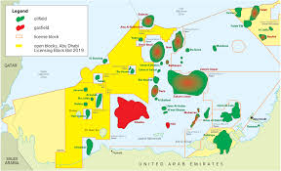
ADNOC CHANCES OF SUCCESS IN ASIA
ADNOC is applying the joint ventures short cut growth and also acquisition in Asia. The employment of the technique is due to the fact that the majority of the government authorities know the challenges that might be presented by the Company if mandated the express autonomy for operating in their nations. The governments seem to be well conversant with the challenges associated with the Company's operation, specifically in foreign nations where the Company seems not to be concerned with the welfare and problems it may cause to the country but majorly driven by its desire to maximize its profits.
Previously, the Company has greatly been accused of gender discrimination, which is a violation of the rights of the majority of the country's citizens, provision of low wages, which in many aspects is considered as a modern form of slavery, strictness with its suppliers as well as the destruction of the small local business because of its financial endowment. In most cases, the Company kills the small available local companies declaring the majority of the citizens employed by these small businesses jobless. Additionally, it poses a challenge in the development of the local innovations and inventions, rendering the country to hugely rely on foreign products and services a case that may result from rising in the exploitation cases and provision of sub-standard or low-quality products as well denying the local consumers an opportunity to enjoy a variety of high-quality products at low prices. Due to these facts, countries like South Korea and Japan ensure they have enhanced strict rules and regulations, thus discouraging foreign investors like ADNOC.
This perception of ADNOC has the probability of influencing its activities and operations in Asia since the Company is perceived as Western ideologies and government representation aiming to modify Western countries' culture. This implies that ADNOC is perceived as to practice modern colonialization, which the eastern governments and authorities are not ready to give, hence posing a threat to its expansion. Therefore, unless Wal-Mart does a reevaluation of its strategies on international expansion, it might not be easy to excel in the Asian Market.
Cultural Diversity
According to Jalilvand, & Westphal, 2017, the arena of international business is highly faced by the problems of cultural differences. Different nations and regions pose different cultures, which greatly influence any particular international business company, especially where these cultures are not put into consideration. This still holds as one of the greatest obstacles of ADNOC in its globalization attempt. The Company's penetration globally is hindered by the cultural difficulties in the various foreign nations of operations. The Company is met with high resistance from the local communities, specifically in the Asian Market, as highlighted above. First, there is a perception among the local communities that the Company is grabbing and encroaching the little available business opportunities for the local small businesses and traders.
In various situations, the local communities have been seen putting more pressure on their authorities to deny the company permission to operate. In this case, the local communities seek to protect their interests through the community dragging in. culture difference is also a responsible determinant for the Company's contention when trying to establish new branches in the retail market in Asia. The community pressure may force the government to work upon it hence disadvantaging the Company's strategic plans for expansion in the particular Asian markets.
The Company's international Division having the mandate to conduct the study in the potential and prospective markets, seems successful in this specific front. However, the Division has failed to set the preferences for the consumers that are influenced in some markets by culture, specifically in most Asian nations. Having adequate information concerning the culture-driven customer preferences and tastes can be a good foundation in establishing a successful prospective market front. This calls for a detailed study of the community culture to understand in which better angle to target the particular market. However, ADNOC seems to have ignored this particular fact, which has, as a result, acted as an obstacle for the establishment and expansion of the Company.
According to Jalilvand, & Westphal, 2017, there exist a number of conflicts between the Company and its client, a situation that has forced the Company to approve amendments that will assist it not to close down the operations in its stores.
Social relationships in India play a major responsibility in financial deals. The aspect still stands in place, even with the presence of globalization for the communities in India. Nonetheless, ADNOC has continued to change this attitude by the community regarding westernization gradually. It has been able to attain an essential customer base with the existence of the small traditional shops. These shops mark the existence of waysides in India. The small traditional markets continue to dominate and control the retail market, and it seems they will continue with the same control and domination to almost eighty-five percent of the local market. These roadside shops may seem to be only slightly larger than a cabinet, but the local consumers highly prefer them. This preference of the local customers' roadside shops is perceived to have been contributed by the high rate of poverty that has pushed the locals to it.
A strong relationship was established between the shop owners and the locals, which even made them qualify for goods on credit whenever they do not have the cash. In contrast with ADNOC, the locals would, therefore, enjoy buying and shopping where there was the availability of credit. ADNOC did not offer credit facilities to the locals. Considering that the disposable income levels might not rise in the near future, the large retail companies should, therefore, desert their latest plans; thus, the chains should aim to become the neighborhood store.
The set of Laws
When engaging in international trade, it is quite inevitable to consider the laws of the state. In UAE, ADNOC is termed as a very powerful investor. In fact, the majority of the market is enjoyed by the Company. This due to its laid strategic plans that have seen it enjoy specific success in UAE. It is evident that most customers enjoy shopping with ADNOC compared to other businesses providing the same commodities, especially the small-scale retailers. However, in other foreign nations, the Company is classified as an overseas investor whose objective is only to exploit the human and financial resources of a country for its profit maximization but rather not for the particular nation's interests. This particular problem manifested itself upon the entry of the China company, which is densely populated, having a potentially large market. The country has more than a hundred and seventy metropolises. To ADNOC company, this was a great potential market for its stores, and it would possibly reap big.
ADNOC companies seek to maximize the large potential market. Nonetheless, the restrictive and stringent regulations of the specific communist government regulations hindered the endeavors of the Company. These governments curtail the Company's expansion by setting up restrictions that limit the Company's operations in a specific foreign country. For example, the Company was boxed in specific counties by the Chinese government in order to regulate competition. In this particular case, the Chinese government saw the need to restrain competition among the local companies and ADNOC in individual counties to protect the small local retailers from the stiff competition and exploitation since it felt that ADNOC had the capacity to do so. Since then, ADNOC is yet to establish an outlet or branch in a flourishing city.
For the case of India, the Indian Federal laws hinder international retailers from investing directly in the Indian economy. This implies that global retailers are, in a way, curtailed in thriving and expanding in the Indian economy as it is not mandated to do so. As a result of this policy, ADNOC has been caught a victim of the restrictions, thus forcing the Company to penetrate the vast Indian market through joint ventures. The Indian government is comparatively young concerning the policy infrastructure; hence, the community's norms are embedded deeply onto the mindset of society. Therefore, this is evidence that society's perspective greatly influences the government, and it is the one that determines the policy infrastructure. The investors, who in most cases are the policymakers, control the processes of decision making substantially. They guide the legislation creation, which implies that any decision on legislation processes must be advantageous to them. Owing to that, they are in favor of small-scale retailers. These decision-makers are the small trade store owners. Therefore, they will ensure that the business encroachment perceived notion by the global companies flows within the government's structures (Narasimhan et al. 2019).
Local Communities
ADNOC plans of opening a new store location in most cases have to be followed by an equivalent municipal civil war as attempts to force itself way in between the anti and pro ADNOC factions. Opponents of the Company majorly highlights the environmental challenges, congestion in the traffic, poor public relations, the safety of the public, low benefits and wages as well as predatory pricing. The opposition by the religious groups, competitors, labor unions, and local individuals may include the destruction of properties in the store buildings, protest marches, or through establishments of bomb scares. Additionally, developers who are planning to incorporate ADNOC in their projects are denied permits by the city councils hence posing a challenge in the Company's expansion plans (Balbahaith, 2018).
Labor concerns overseas
The Company continues to be criticized for failing to avail of its foreign suppliers' adequate supervision. Additionally, it is criticized for using prison labor and sweatshops. The low-price high cost depicts images of the poor conditions of the Company's commodities producing factories and also the inhumane conditions and abuse that the factories workers are subjected to. Some of these factors and conditions can be termed as the reason why most of the authorities and governments are reluctant to guarantee ADNOC automatic access to their markets as they consider the effects that might be resulted.
The current monitoring process that is used by ADNOC is considered inadequate and poses a hindrance to the verification of the conditions by the outsiders. ADNOC fails to release its factory names or audits, thus forcing the outside organizations only to accept the claims by ADNOC as facts. The Company started to operate with a California based non-profit organized Business for Social Responsibility to reach out to active groups in monitoring factories overseas.
In 2006, the Company got excluded from the Government Pension Fund of Norway investment portfolio, which had stock values in the Company of around $430 million because of the social audit into the labor rights violations in the Company's operations in Africa, Asia, Latin America, Canada as well in the United States.
On Nov 24, 2012, in Bangladesh, a fire in a clothing factory led to the death of a hundred and twelve workers. The survivors of the tragedy claimed that the fire extinguishers failed to operate; the emergency door was locked. When the alarm was off, the workers were instructed by the managers to return to the sewing machines. The victims jumped or trapped to their deaths from the story building, which lacked fire exits or escapes. Having experienced this from other nations, the majority of the governments may find it difficult to allow the Company the rights to take its operations freely as they fear the possible outcomes that may result. The foreign Companies has therefore been branded as irresponsible on matters concerning the safety of its workers and employees.
The rapid decline of the oil prices and the slowing demand growth have forced the Abu Dhabi National Oil Company to divert on ho to slow the expansion capacity of the projects for cutting the costs. In a statement by Abdullah Nasser, the deputy chief executive of the company, he said that the company can wait and it will wait for the expansion plans. However, he highlighted that the main plans and objectives of the company are not affected due to the requirement of sustaining out production and move on with it. This implies that the objective of the company of expanding the production capacity to about 3.5 barrels in a day now became a ten-year project.
Technological challenges

Lu et al. 2019 notes that like any other international company, ADNOC is experiencing technological challenges in most foreign nations, especially in Africa and Asia. Most countries in the two continents have not developed technical wise to meet the required expectations. In most cases, these countries' technological advancement is no near the one for the UAE, United States and the United Kingdom. In most cases, international companies may find it challenging to carry out their operations with ease, as it would be the case where technology has dramatically developed. Technological challenges can be linked to the low rates of establishments, penetration, and dominance of ADNOC in the majority of the foreign nations.
ALTERNATIVES
Although ADNOC is doing excellent job especially having stock of fertilizers, the retailer requires to emphasize on quality improvement of the commodities in the shelves. This includes conducting employees training to recognize where there is a problem that requires to be fixed. The company should also opt to the provision of healthier products and a wide natural varieties and organic products especially in foreign countries whose consumption is culture oriented.
Alternatively, the company should put more identify and focus on the markets that it has established and dominated in rather than concentrating on those areas that have high resistance. By doing so, the retailer will save on the huge costs that may be incurred in the nations that are difficult to penetrate and dominate.
SOLUTION
Most of the challenges experienced by the company can be resolved internally by establishing new and better policies especially those whose focus is for the betterment of the society rather than profit maximization. This includes better treatments of the workers through the provision of better wages and benefits. The company should put more focus on the welfare of the particular communities as a way of gathering their support.
Additionally, the company should conduct better evaluation and research on the cultural aspects of the communities before developing the expansion strategies. This will be essential in providing the company with all the necessary knowledge and information regarding the particular market which will assist it to develop better market strategies and approaches. Adhering to the rules and regulations of the authorities can also be critical in solving the experienced company challenges.
CONCLUSION
ADNOC desire to put more emphasis on foreign markets has high potentials, such as India, instead of those where competition is already high such as Brazil and the United Kingdom. However, these efforts are becoming complicated due to the various associated challenges that are hindering its dominance and expansion in the foreign markets.
Similar to ADNOC cases, other companies such as Saudi Aramco have also invested heavily in the global markets and continues to strategize on the expansion in the foreign markets. The strategy is essential to the two companies since, even if the Asian market is valuable incredibly, it is already highly competitive. Additionally, it provides lower rates of growth compared to most of the emerging markets. However, the main determinant for the penetration and expansion in these new markets is determined by how keen every Company is in establishing its strategies and evaluating the various obstacles presented in the foreign markets. How the Company also carries its operations majorly considering the cultural factors.
RECOMMENDATIONS
These challenges hindering ADNOC expansion in the international markets need to be reevaluated and sorted out for a better share of the Company in the international market. Working out these issues will be crucial for ADNOC future rivalry with Aramco. Considering the case for Aramco specifically, the global markets are required to boost progress for the major subscriber base, which is proceeding towards saturation. For Aramco to excel in high markets of high growth, specifically the ones that Aramco is in or has interests in, ADNOC will be required to thrust its businesses and operations to better and new heights with Aramco in the upcoming days. Therefore, ADNOC is required to up its games to establish itself, penetrate, and dominate these foreign markets.
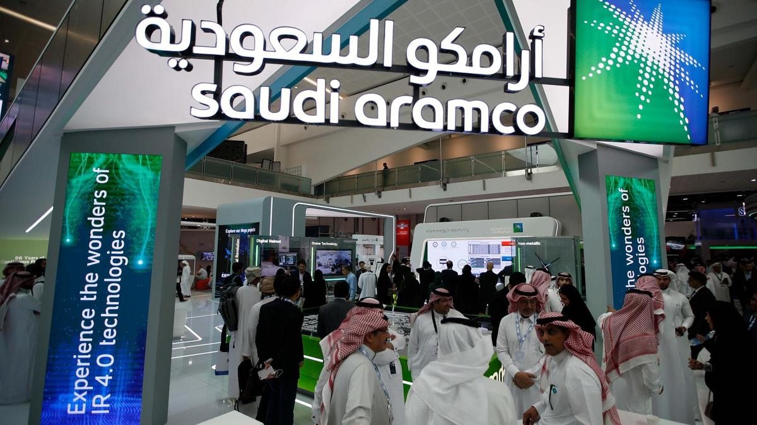
ADCON and Saudi Aramco launching oil supply in conjunction.

References
Balbahaith, A. (2018, November). Business Process Improvement in ADNOC Gas Processing through Lean Kaizen Approach. In Abu Dhabi International Petroleum Exhibition & Conference. Society of Petroleum Engineers.
Burguera, P. M. (2020, November). Digital Experimentation to Meet the Challenges of Sustainable and Safe Energy. In First EAGE Digitalization Conference and Exhibition (Vol. 2020, No. 1, pp. 1-5). European Association of Geoscientists & Engineers.
Jalilvand, D. R., & Westphal, K. (Eds.). (2017). The political and economic challenges of energy in the Middle East and North Africa. Routledge.
Lu, H., Huang, K., Azimi, M., & Guo, L. (2019). Blockchain technology in the oil and gas industry: A review of applications, opportunities, challenges, and risks. Ieee Access, 7, 41426-41444.
Narasimhan, T., Molelputhenpura, K., Adel, K., & Al Awadhi, I. (2019, November). Fit for Future Challenge–Optimizing the Specifications. In Abu Dhabi International Petroleum Exhibition & Conference. Society of Petroleum Engineers.

